ASSESSMENT TOOL 1 – High (Coding Challenge)
Question 1: Library Book Management
CODE:
class Book {
private int bookId;
private String title;
private String author;
private double price;
private boolean issued;

Book(int id, String t, String a, double p) {
bookId = id;
title = t;
author = a;
price = p;
issued = false;
}

void issueBook() {
if (!issued) {
issued = true;
System.out.println("Book Issued");
} else {
System.out.println("Already Issued");
}
}

void returnBook() {
issued = false;
System.out.println("Book Returned");
}

void display() {
System.out.println(bookId + " " + title + " " + author + " " + price);
}
}

public class Main {
public static void main(String[] args) {

Book b1 = new Book(101, "Java", "James", 500);

b1.display();
b1.issueBook();
b1.returnBook();
b1.display();
}
}
OUTPUT :
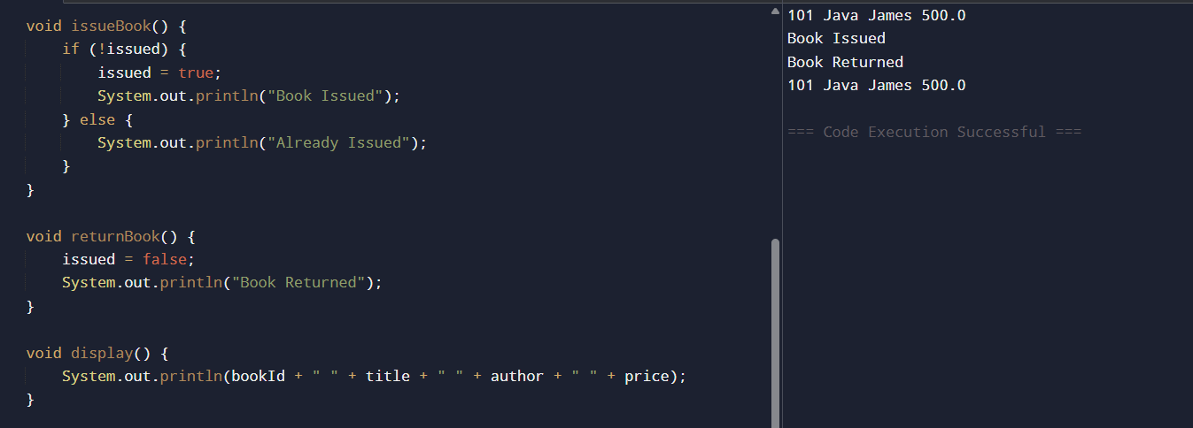

Question 2: Employee Payroll System using Inheritance
CODE:
class Employee {
String name;

Employee(String name) {
this.name = name;
}

void calculateSalary() {
System.out.println("Salary");
}
}

class PermanentEmployee extends Employee {

PermanentEmployee(String name) {
super(name);
}

void calculateSalary() {
System.out.println("Permanent Employee: " + name);
System.out.println("Salary = 50000");
}
}

class ContractEmployee extends Employee {

ContractEmployee(String name) {
super(name);
}

void calculateSalary() {
System.out.println("Contract Employee: " + name);
System.out.println("Salary = 25000");
}
}

public class Main {
public static void main(String[] args) {

Employee e;

e = new PermanentEmployee("Ravi");
e.calculateSalary();

System.out.println();

e = new ContractEmployee("Ram");
e.calculateSalary();
}
}
OUTPUT:
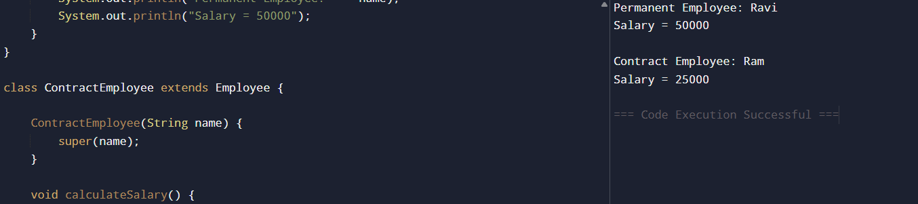

Question 3: Vehicle Rental System using Runtime Polymorphism
CODE:
class Vehicle {

void calculateRent(int days) {
System.out.println("Rent");
}
}

class Car extends Vehicle {

void calculateRent(int days) {
System.out.println("Car Rent = " + (days * 1000));
}
}

class Bike extends Vehicle {

void calculateRent(int days) {
System.out.println("Bike Rent = " + (days * 300));
}
}

class Bus extends Vehicle {

void calculateRent(int days) {
System.out.println("Bus Rent = " + (days * 2000));
}
}

public class Main {

public static void main(String[] args) {

Vehicle v;

v = new Car();
v.calculateRent(2);

v = new Bike();
v.calculateRent(2);

v = new Bus();
v.calculateRent(2);
}
}
OUTPUT:

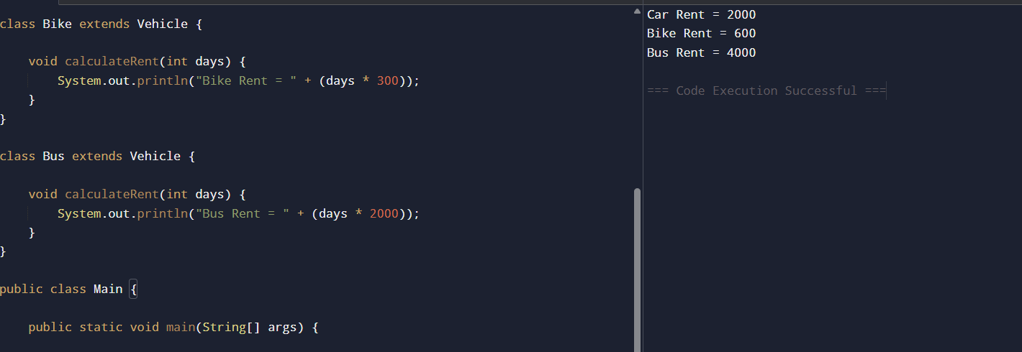

Question 4: Bank Account System using Data Hiding
CODE:
class BankAccount {
private int accountNumber;
private String holderName;
private double balance;

BankAccount(int accNo, String name, double bal) {
accountNumber = accNo;
holderName = name;
balance = bal;
}

void deposit(double amount) {
balance = balance + amount;
System.out.println("Deposited: " + amount);
}

void withdraw(double amount) {
if (amount <= balance) {
balance = balance - amount;
System.out.println("Withdrawn: " + amount);
} else {
System.out.println("Insufficient Balance");
}
}

void displayBalance() {
System.out.println("Account No: " + accountNumber);
System.out.println("Holder Name: " + holderName);
System.out.println("Balance: " + balance);
}
}

public class Main {
public static void main(String[] args) {

BankAccount b = new BankAccount(101, "Monika", 5000);

b.displayBalance();

b.deposit(1000);

b.withdraw(2000);

b.displayBalance();
}
}
OUTPUT:

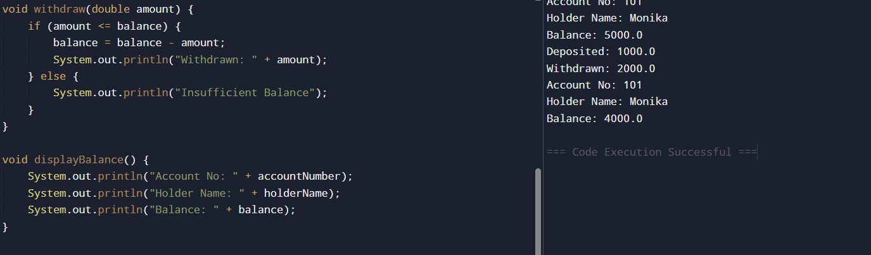

Question 5: University Admission System using Method Overloading
CODE:
class Admission {

void calculateFee() {
System.out.println("UG Fee = 50000");
}
void calculateFee(int pg) {
System.out.println("PG Fee = 70000");
}
void calculateFee(String scholarship) {
System.out.println("Scholarship Fee = 20000");
}
}
public class Main {
public static void main(String[] args) {
Admission a = new Admission();
a.calculateFee(); // Undergraduate
a.calculateFee(1); // Postgraduate
a.calculateFee("Yes"); // Scholarship
}
}
OUTPUT:
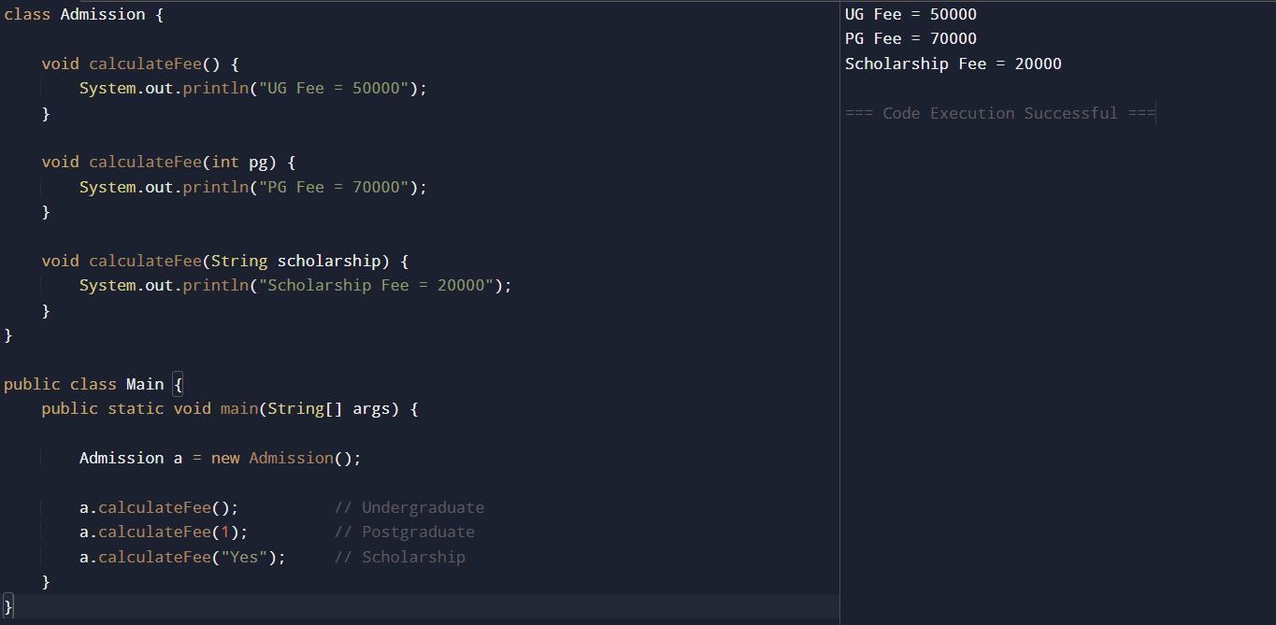
Question 6: Shape Area Calculator using Abstract Class & Polymorphism
CODE:
abstract class Shape {
abstract void area();
}

class Circle extends Shape {
void area() {
double r = 5;
System.out.println("Circle Area = " + (3.14 * r * r));
}
}

class Rectangle extends Shape {
void area() {
int l = 5, b = 4;
System.out.println("Rectangle Area = " + (l * b));
}
}

class Triangle extends Shape {
void area() {
int b = 4, h = 6;
System.out.println("Triangle Area = " + (0.5 * b * h));
}
}

public class Main {
public static void main(String[] args) {

Shape s;

s = new Circle();
s.area();

s = new Rectangle();
s.area();

s = new Triangle();
s.area();
}
}
OUTPUT:

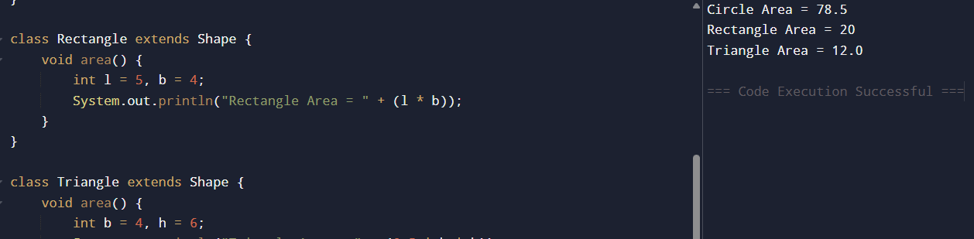

Question 7: Hospital Management System using Interfaces
CODE:
interface MedicalRecord {
void addRecord();
void displayRecord();
}

class Patient implements MedicalRecord {

public void addRecord() {
System.out.println("Patient Record Added");
}

public void displayRecord() {
System.out.println("Patient Name: Monika");
}
}

class Doctor implements MedicalRecord {

public void addRecord() {
System.out.println("Doctor Record Added");
}

public void displayRecord() {
System.out.println("Doctor Name: Ravi");
}
}

public class Main {
public static void main(String[] args) {

MedicalRecord m;

m = new Patient();
m.addRecord();
m.displayRecord();

System.out.println();

m = new Doctor();
m.addRecord();
m.displayRecord();
}
}
OUTPUT:

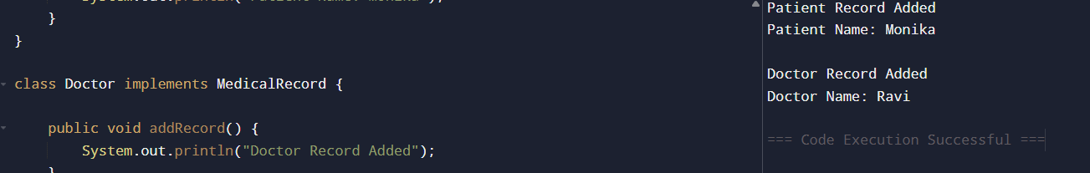

Question 8: Online Shopping Order System using Packages
CODE:
class Product {
int price = 500;
String name = "Laptop";
}

class Order {
void placeOrder() {
Product p = new Product();
System.out.println("Product : " + p.name);
System.out.println("Price : " + p.price);
System.out.println("Order Placed");
System.out.println("Total Amount = " + p.price);
}
}

public class Main {
public static void main(String[] args) {
Order o = new Order();
o.placeOrder();
}
}
OUTPUT:
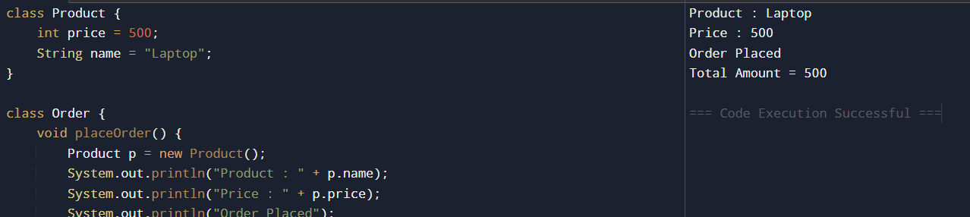
Question 9: Student Result Analyzer using Arrays of Objects
CODE:
class Student {
int roll;
String name;
int m1, m2, m3;
Student(int r, String n, int a, int b, int c) {
roll = r;
name = n;
m1 = a;
m2 = b;
m3 = c;
}
int total() {
return m1 + m2 + m3;
}
void display() {
int total = total();
double avg = total / 3.0;
String grade;
if (avg >= 90)
grade = "A";
else if (avg >= 75)
grade = "B";
else if (avg >= 50)
grade = "C";
else
grade = "Fail";
System.out.println(roll + " " + name);
System.out.println("Total = " + total);
System.out.println("Average = " + avg);
System.out.println("Grade = " + grade);
System.out.println();
}
}
public class Main {
public static void main(String[] args) {
Student s[] = {
new Student(1, "Monika", 90, 95, 85),
new Student(2, "Ravi", 80, 70, 75)
};
int max = s[0].total();
String topper = s[0].name;
for (Student x : s) {
x.display();
if (x.total() > max) {
max = x.total();
topper = x.name;
}
}
System.out.println("Class Topper = " + topper);
}
}
OUTPUT:

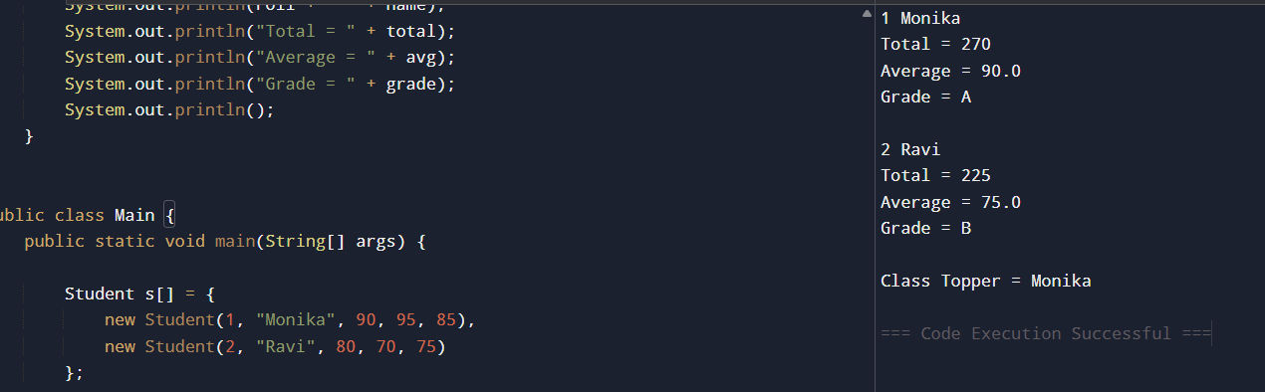

Question 10: Smart Home Device Controller using Hierarchical Inheritance
CODE:
class Device {
void turnOn() {
System.out.println("Device ON");
}
void turnOff() {
System.out.println("Device OFF");
}
void power() {
System.out.println("Power");
}
}
class Light extends Device {
void power() {
System.out.println("Light Power = 20W");
}
}
class Fan extends Device {
void power() {
System.out.println("Fan Power = 75W");
}
}
class AirConditioner extends Device {
void power() {
System.out.println("AC Power = 1500W");
}
}
public class Main {
public static void main(String[] args) {
Device d;

d = new Light();
d.turnOn();
d.power();
d.turnOff();
System.out.println();
d = new Fan();
d.turnOn();
d.power();
d.turnOff();
System.out.println();
d = new AirConditioner();
d.turnOn();
d.power();
d.turnOff();
}
}
OUTPUT:

